BIBLE PATHWAY MISSION-LIBERIA, INC
Lower Virginia, Red hill Field, P.O box 1764,
Email:biblepathlib@gmail.com
Monrovia, Liberia

BPM-LIB NEWS LETTER-JULY, 2020

In spite of the pandemic covering us all, the month of July was a great month in which we saw the Lord’s divine power, strength and manifestation in His church and in our Ministry. We had great outreaches and saw many people coming to the salvation of the Lord Jesus Christ. Indeed, this month was another blessed month, although the devil always stands against any good thing the Lord is doing for His people. We thank God that we were allowed at last to have our services, even though they were not our normal services.

CHURCH ACTIVITIES

WORSHIP SERVICES:
Our worship services this month were not usual, as the time allowed to hold them, given to us by the government, was not very long. So, therefore, our services were mostly preaching, teaching and worship which was followed by prayers for the world and for our nation of Liberia. Our worship services, were however, filled with the Holy Spirit and there was healing, a fall of anointing as many spoke in tongues. Indeed, our prayers were filled with having God finish with the coronavirus in our world at large.

NEW CHURCH PLANTING:
We have also started planting a new church at the site where we are building the missionary and pastor’s lodge. It is our plan that here we will have the Bible Pathway Mission-Liberia headquarters. We have started by erecting the poles with which we are going to build a temporary structure for the church building. We have also started our normal evangelism. We currently have over 30 people waiting for the erection of the temporary building to be completed in order to start holding worship services there.

VILLAGE EVANGELISTIC CRUSADE AND BIBLE CONFERENCE:

We wish to have an Evangelistic Crusade and Bible Conference in the villages as soon as the country is opened back up for travel between counties. This is a vital part of our Ministry at Bible Pathway Mission-Liberia. Previously, many un-reached people come to these conferences whenever they hosted nearby them. During our last one, more than two thousand people were saved and many more were also healed and delivered. Please pray about helping with the finances necessary to host these Conferences. We are anticipating to host one in December this year when the country open up back.

SUPPLY OF FOOD TO THE DESPERATE:
We are thankful to the Lord for allowing our friends & partners to contribute to help the desperate members of our church with food. During this month, we had a shortage of rice in Liberia. The rice we did have in the country was very expensive to purchase. Indeed, it was not affordable at that time, nor presently, to our most desperate. When our partners sent the funds we were able to buy food here and distribute it to the most desperate people associated with BPM-LIB. We pray that the Lord will greatly bless our partners for having such kind hearts that are so open to the leading of the Holy Spirit in responding to the needs of our people. These swift actions taken by our partners saved lives!

THE SCHOOL OF ORPHANS (BOTH IN THE VILLAGE & MONROVIA):

We are having two schools in Liberia currently where we train and educate orphans. These orphans are catered to and are supported through out their learning process. Your contribution will help support a child, it will help pay the teachers and it will also help feed them. The two schools are called, THE SAMUEL’S CALL INTERNATIONAL and THE VICTORY ACADEMIC SCHOOL. In all of our schools we have a total of 250 children and our grade level is from the nursery to the 6th grade.

- SAMUEL’S CALL/MONROVIA: The orphan students in Monrovia are not attending classes at this time as the government has shut down all schools in the country because of Covid-19. They were not able to complete the second semester in order to have their promotions this year. It was very discouraging to the children when they were told they could not attend classes during this onset of Covid-19. However, in this month, we thank God that the government has just announced the reopening of schools in August when the second semester will be completed. We are preparing at this time to start classes with our children. We need prayers to have school supplies and also to be protected from flooding for the months of August and September, as those are heavy flood months in Monrovia. Our school is located on low lying ground and is very susceptible to flooding! If we have flooding during these months, it will once again interrupt our class scheduling and may affect not only the children’s graduations, but can cause much sickness and many other things. The flood will also interrupt with our normal services for in the same place we have the school in Monrovia is in the same place the church and the pastor’s house are in.

- VICTORY ACADEMIC SCHOOL/THE VILLAGES: It is a joy to let you all know that we also have another school of orphans in the villages. We have been holding classes with them but because of Covid-19, this school was also closed. We also plan to resume classes there in September. We are working on the plans to reopen the school in the villages. We will send you updates in our next monthly newsletter in August. We have 100 children that are enrolled in our village school and we have four teachers there. We will appreciate your prayers for the salaries of the teachers and the school supplies there as well. We have school supplies in the US waiting for funds to be shipped to Liberia. Please contact our US International Office if you can help with this project!

THE BUILDING OF THE PASTOR’S AND MISSIONARY LODGE:
The building is near completion but we still have some areas outstanding. The budget below is what we are in need of to complete the building:

ITEM NAME AMOUNT
(In US Dollars)
FLOOR………………....………………. $3,200.00
WINDOWS………………………...........1,850.00
ELECTRICITY…………………..............2,000.00
PLUMBING………………………….......900.00
PAINTING………………………….........700.00
TOILET………………………………........800.00
CONTINGENCY (for rising/fluctuating material/labor costs)...............2,000.00

TOTAL.................................$12,450.00

It is our prayer that the Lord will provide the above needed budget to complete this building before the end of August or this year. We are thinking of the type of flooding that can occur here during the heaviest months of rain, causing severe flooding in August and especially in September. It will be a blessing to transfer (move) to our new building before the month of September, Lord willing, before we are attacked and displaced by flooding.

UPDATE ON LIBERIA:

CONRONAVIRUS: I have not seen any actual Covid-19 patients since it was pronounced that Liberia had active positive cases. I remained very doubtful that we really have Covid-19 in Liberia at all. However, we cannot underestimate the possibility of anything especially during such a time where the world is turning into something else. The government, however, has finally lifted the lockdown and the movement of people is now unrestricted as of the 21st of July. The Robert International Airport, post offices and other government institutions have also been reopened. We are now allowed to hold and attend our services which have made us able to resume our midweek services and Bible conferences on Fridays in Monrovia, as well as now hosting our normal worship service. School will be opened in late August (or September). I think our nation has been reopened again. We thank God that none of our members was affected by the disease and that everyone is well.

The government however, is reinforcing the health laws of Liberia wherein they are asking everyone to wear masks and practice social distancing especially at public places. It is spelled out in their report that we now have 780 total confirmed cases of Covid-19 in Liberia and 36 deaths of Covid-19.

SHORTAGE OF RICE/ ECONOMY:

Liberia has gone through many tough times since the end of the civil war and this has caused a lot of suffering for the Liberian people. Right now, according to the World Bank, the majority of households living in Liberia is reported to be below the international poverty line. It is projected that those living in poverty was raised to 65.2% in 2020 under the baseline scenario and to 68.2% under the downside scenario. The World Bank has clearly projected that an additional 335,000 to 526,000 Liberians are now at risk of falling below the international poverty line in 2020, in addition to those who were already there. The World Bank also projected that the path to Liberia’s economic recovery will be especially challenging due to the country’s vulnerable public health and economic impacts from COVID-19, lack of National monetary reserves, a failed infrastructure, depressed educational system and also that the country’s range of potential policy responses from its government are limited and narrow. It is surprising to know, however, that right now we have a shortage of rice and the little rice that is around has increased so much in price that many Liberians cannot afford to buy even half a bag. Rice is the main component of the Liberian diet. With this, I foresee many children not being able to return to school at this time-as there are no jobs; their parents are not able to afford to pay their school fees. Health facilities also continue to exist without medicines. What medications are here, are also not affordable. I am also foreseeing and upcoming of farming in the country where in our children may be left without food hence many may face death. Currently and before the covid-19, more than half percent of our children in Liberia couldn’t afford school fees to go to school for which our ministry has an opened hand in helping these children in any way we can. Please continue to pray for this nation.

PRAYER REQUESTS:

- Pray that Jessica Joshua recovers rapidly, she has been sick since the 20th of July of malaria, typhoid and infections.

- Pray for Pastor Philip to be healed, he is having sharp pain in the upper part of his leg.

- Pray for the weather conditions in Monrovia, that there will be no flooding and that the heavy rains will cease.

- Please pray also that we have the building at the new site completed so that the pastor and his family can transfer (move) from the low-lying flood plane to the higher and safer land.

- Pray for the continued health, availability of food and stable housing for Bible Pathway members. Due to the many recent critical situations that we have faced, we are now operating without any financial reserves. Pray that God will provide the necessary funds for us to continue our Ministry outreaches and functions.
PHOTOS OF SOME OF OUR ACTIVITIES
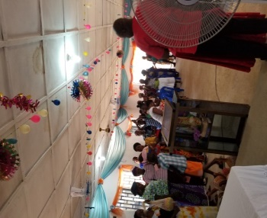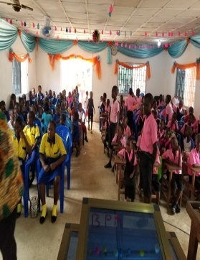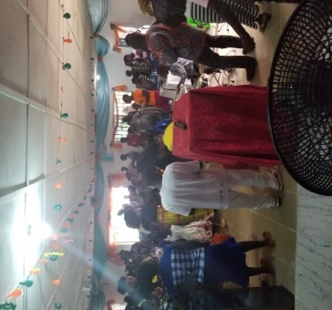
The congregation during service and our school children in devotion

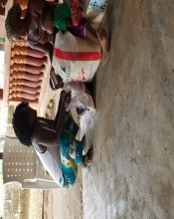 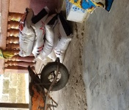 Food distribution

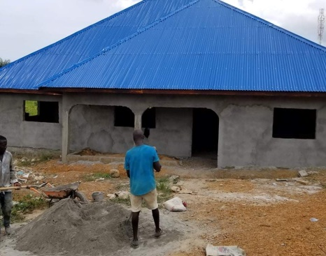
Pastor and missionary building or lodge, undergoing building

For more information on what we are doing in mission in Liberia, please visit our web link below:
https://biblewaypathwaymission-liberiaicom.yolasite.com/
On the mission field,
Philip & Jessica Joshua-Monrovia, Liberia.

